# CS 255 System Design Document Template

This template lays out all the different sections that you need to complete for Project Two. Each section has guidance to prompt your thinking. You will need to continually reference the interview transcript as you work to make sure that you are addressing your client’s needs. There is no required length for the final document. Instead the goal is to complete each section based on what your client’s needs are. Remove this note when you are finished, and replace all bracketed text with the relevant information.

## UML Diagrams

### UML Use Case Diagram

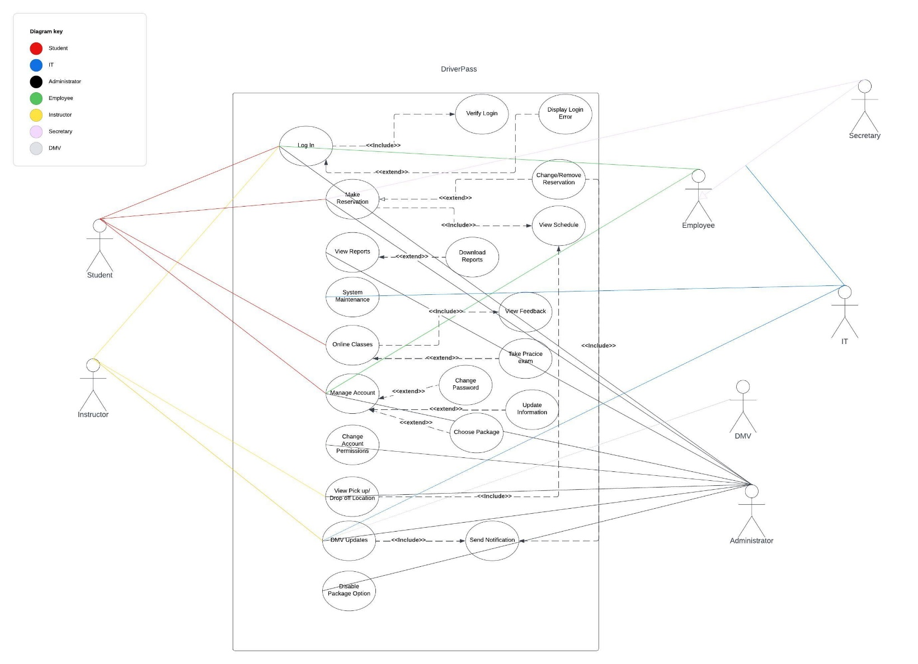

### UML Activity Diagrams

UML Activity Diagram Schedule Update

Download Report Activity Diagram

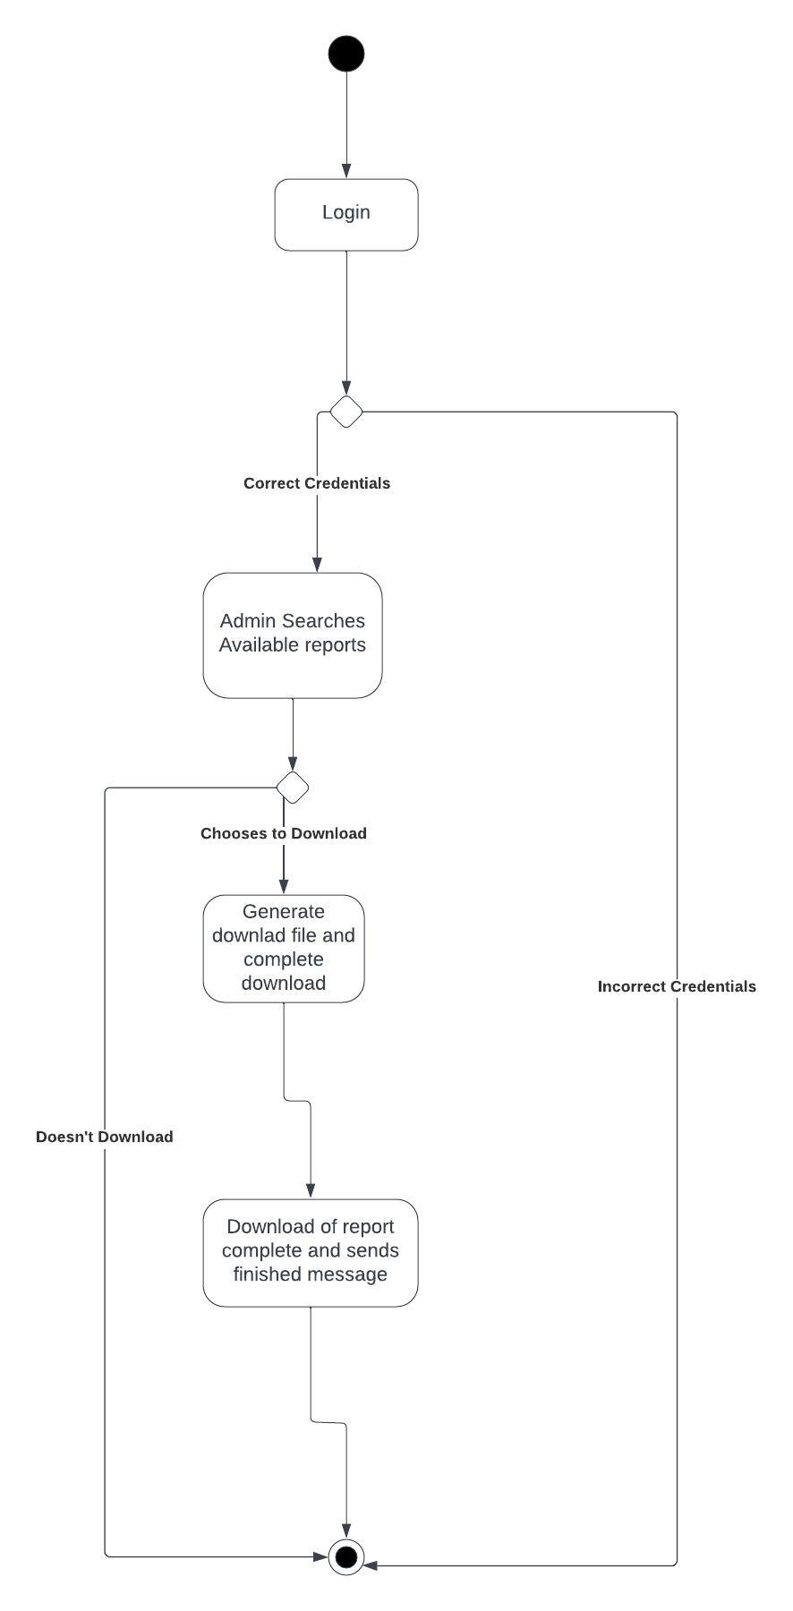

### UML Sequence Diagram

### UML Class Diagram

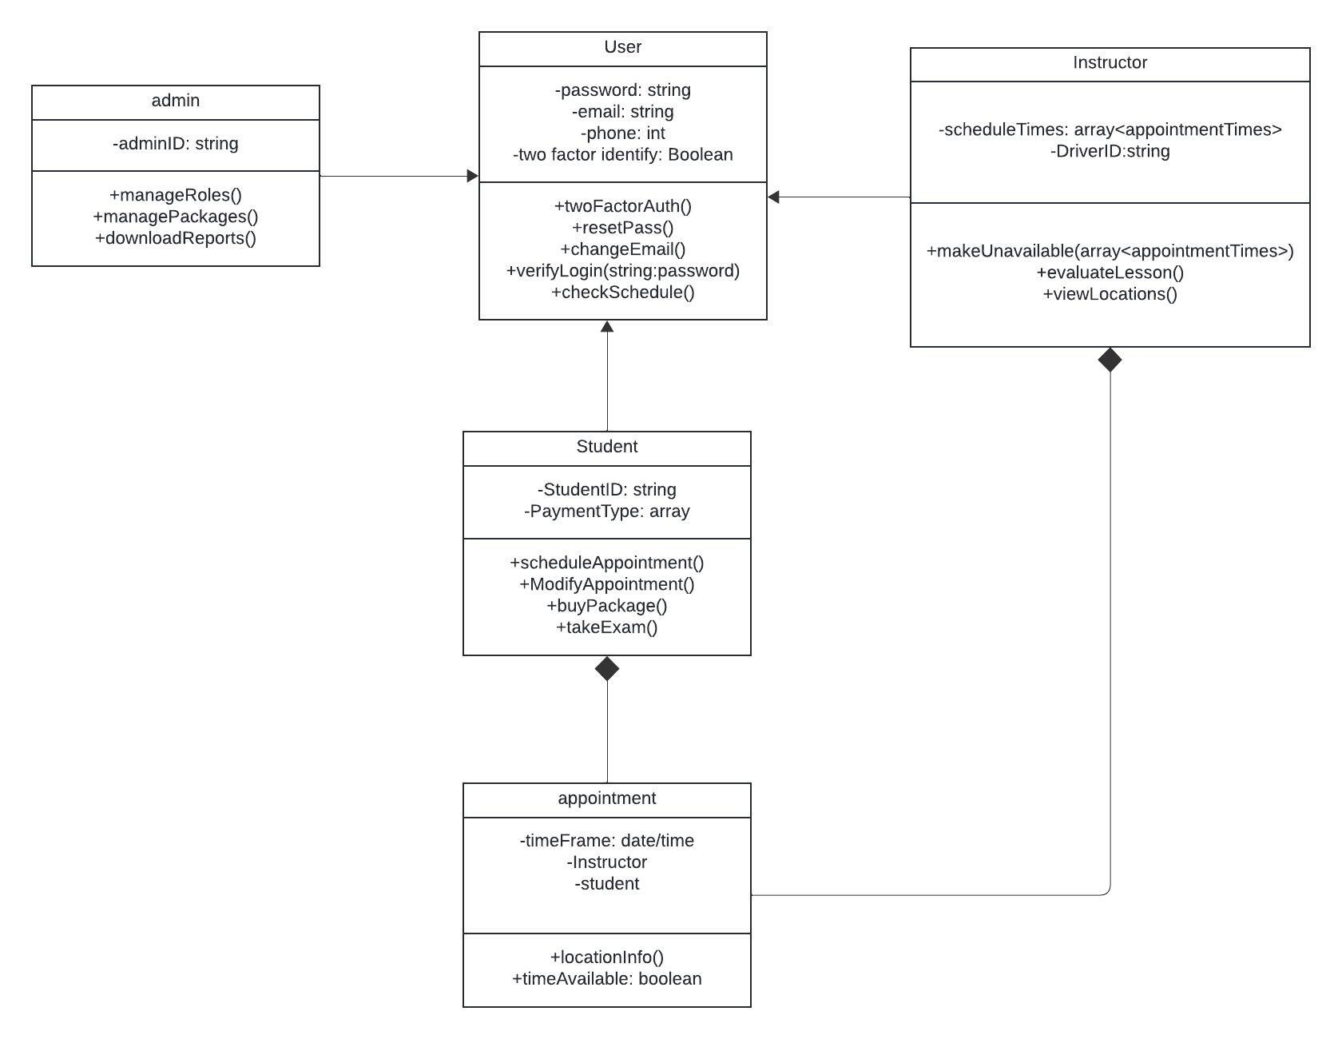

## Technical Requirements

*[Based on the diagrams you have created, describe the technical requirements of your system. These requirements should address the required hardware, software, tools, and infrastructure necessary for your system design.]*

Data accessibility able to access anywhere at any time on any device, but only update database during online session.

Tracking and activity reports that are downloadable by the administrator in an easy to read format which shows who modified the schedule, what drivers are with what students and receive notifications whenever DMV rules change, or someone changes the schedule and who that was.

Integrated security so that the employees won’t have to manage security themselves, and easy access for IT officer in order to implement updates.

User types and role management that will allow the administrator to change role access and permissions based on the persons role in the company.

Ability for students to view, modify and change/add scheduled driving lessons.

Cloud connectivity

Simple yet effective programming which will run quickly and efficiently on all major browsers/devices.

Recommended javaScript coding language for its versatility and ease of use and online capabilities.